Wexford Town CCTV Project.

Public Consultation.

Wexford Borough District Office,

61 The Bull Ring,

Ferrybank South,

Wexford,

Y35 EA00.

Public Consultation
CCTV System – Wexford Town.

1.0 Introduction

1.1 Wexford County Council in association with An Garda Siochana are considering the upgrade of the existing 33 camera Closed Circuit Television System in Wexford Town Centre and the addition of 16 new cameras at 12 additional locations throughout the Town.

2.0 CCTV System Objectives;

2.1 The main objectives of the Wexford Town Centre CCTV system are to;
1. Provide a deterrent to crime and anti-social behaviour.
2. Improve public safety.
3. Assist emergency services when investigating an incident.
4. Gather evidence for the detection and prosecution of persons who may have been involved in criminal activity.
5. Assist the Local Authority in the management of public areas.

3.0. Proposed Camera System.

3.1 The proposed system will consist of multi-sensor cameras, Fixed lens bullet and dome cameras, PTZ cameras and LPR cameras. The total number of cameras proposed at 32 locations throughout the town is 49 ie;

- 1 x 4 lens multi-sensor IP cameras,
- 3 x 3 lens multi-sensor IP cameras,
- 1 x outdoor dome IP cameras.
- 43 x outdoor bullet IP cameras.
- 1 x indoor dome IP camera – Comms Room at Wexford Library.

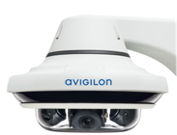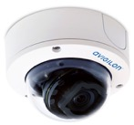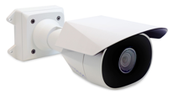
Multi-Sensor Camera. Dome Camera Bullet Camera

3.2 The system will provide CCTV coverage of Wexford Town Centre and suburbs in line with Wexford County Council and Garda requirements.

3.3 The CCTV server will be based at Wexford Town Library.

3.4 Wexford County Council will be the Data Controllers for the CCTV system and Wexford County Council will manage all Data Protection/GDPR matters related to the system.

4.0 – Example of WCC CCTV Signage.

